**Bahria University,**

**Karachi Campus**



## LAB EXPERIMENT NO.

6

## LIST OF TASKS

|  |  |
| --- | --- |
| **TASK NO** | **OBJECTIVE** |
| **1** | Using python implements VADER rulesbased classification algorithm to find the sentiments of different sentences. |
| **2** | :Using python implements textBlob rules-based classification algorithm to find the sentiments of different sentences and compare the results with task # 01. |

Submitted On:

25 feb 2024

(Date: DD/MM/YY)

**TASK # 1:** Using python implements VADER rulesbased classification algorithm to find the sentiments of different sentences.

import nltk

from nltk.sentiment import SentimentIntensityAnalyzer

import matplotlib.pyplot as plt

sid = SentimentIntensityAnalyzer()

def analyze_sentiment_and_generate_pie_chart(sentence):

    scores = sid.polarity_scores(sentence)

    compound_score = scores['compound']

    if compound_score >= 0.05:

        sentiment = "Positive"

    elif compound_score <= -0.05:

        sentiment = "Negative"

    else:

        sentiment = "Neutral"

    print(f"Sentence: {sentence}\nScores: {scores}\nSentiment: {sentiment}\n")

    labels = ['Positive', 'Neutral', 'Negative']

    sizes = [scores['pos'], scores['neu'], scores['neg']]

    colors = ['yellowgreen', 'gold', 'lightcoral']

    explode = (0.1, 0, 0)

    plt.pie(sizes, explode=explode, labels=labels, colors=colors, autopct='%1.1f%%', shadow=True, startangle=140)

    plt.axis('equal')

    plt.title('Sentiment Analysis Result')

    plt.show()

if __name__ == "__main__":

    sentence = input("Enter a sentence: ")

    analyze_sentiment_and_generate_pie_chart(sentence)

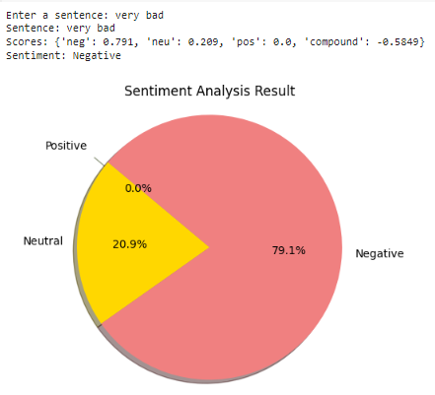

**TASK # 2:** Using python implements textBlob rules-based classification algorithm to find the sentiments of different sentences and compare the results with task # 01

import matplotlib.pyplot as plt

from textblob import TextBlob

import nltk

from nltk.sentiment import SentimentIntensityAnalyzer

def get_textblob_sentiment(sentence):

    analysis = TextBlob(sentence)

    return analysis.sentiment.polarity

def get_vader_sentiment(sentence):

    sid = SentimentIntensityAnalyzer()

    scores = sid.polarity_scores(sentence)

    return scores['compound']

def display_comparison_pie_chart(textblob_polarity, vader_compound):

    labels = ['TextBlob', 'VADER']

    sizes = [textblob_polarity, vader_compound]

    colors = ['lightblue', 'lightgreen']

    explode_distance = 0.1

    explode = (explode_distance if textblob_polarity < 0 else 0, explode_distance if vader_compound < 0 else 0)

    plt.pie(sizes, explode=explode, labels=labels, colors=colors, autopct='%1.1f%%',

            shadow=True, startangle=90)

    plt.axis('equal')

    plt.title('Sentiment Analysis Comparison')

    plt.show()

if __name__ == "__main__":

    sentence = input("Enter a sentence for sentiment analysis: ")

    textblob_polarity = get_textblob_sentiment(sentence)

    vader_compound = get_vader_sentiment(sentence)

    print(f"TextBlob Sentiment Polarity: {textblob_polarity}\nVADER Sentiment Compound: {vader_compound}")

    textblob_pie_value = (textblob_polarity + 1) * 50

    vader_pie_value = (vader_compound + 1) * 50

    display_comparison_pie_chart(textblob_pie_value, vader_pie_value)

